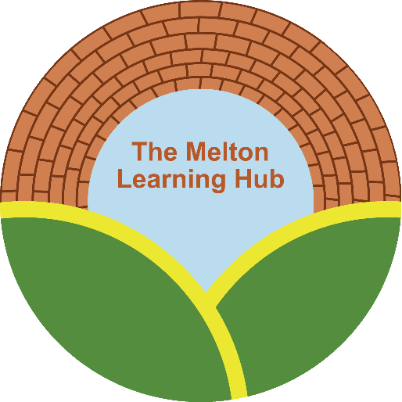

IT Services
Privacy Notice for Pupils

Document title: | Privacy Notice for Pupils
Version number: | 1.1
Policy Status | Approved
Date of Issue | September 2025
Date to be revised | September 2027

Privacy notice
As a pupil at the Melton Learning Hub, you have a legal right to be told about how our organisation uses any personal information that is held about you. To do with this, we provide a ‘privacy notice’ to you to explain what we do with your data.
This privacy notice explains how we collect, store and use personal data about you. Under the law, we, the Melton Learning Hub , are the ‘data controller’.
Our Data Protection Officer is Sarah Cox (see ‘Contact us’ below).

The personal data we hold
We hold some information about you to make sure we can help you learn and look after you at your centre.
For the same reasons, we get information about you from some other places too – like your parents, other schools, the local council and the government.
This information includes:
- Your contact details;
- Your test results;
- Your attendance records;
- Your characteristics, like your ethnic background or any special educational needs;
- Any medical conditions you have;
- Details of any behaviour issues or exclusions;
- Photographs;
- security video images.

Why we use this data
We use this data to help run your centre, including to:
- Get in touch with you and your parents when we need to;
- Check how you’re doing in exams and work out whether you or your tutors need any extra help;
- Track how well the centre is doing;
- Look after your wellbeing.

Our legal basis for using this data

We will only collect and use your information when the law allows us to. usually, we will use your information where:
- We need to comply with the law;
- We need to use it to carry out a task in order to provide you with an education. Sometimes, we may also use your personal information where:
- You, or your parents/carers have given us permission to use it in a certain way;
- We need to protect you or someone else.
Where we have got your permission to use your data, you or your parents/carers may withdraw this at any time. We will make this clear when we ask for permission, and explain how to go about withdrawing permission.
Some of the reasons listed above for collecting and using your information overlap, and there may be reasons which mean we can use your data.

Collecting this information
While in most cases you, or your parents/carers, must provide the personal information we need to collect, there are some occasions when you can choose whether or not to provide the data.
We will always tell you if you have a choice. If you must provide the data, we will explain what might happen if you don’t.

How we store this data
We will keep personal information about you while you are a pupil at our centre. We may also keep it after you have left the centre, where we are required to by law.
We have a Data Retention Policy which explains how long we must keep information about pupils.

Data sharing
We do not share personal information about you with anyone outside the centre without permission from you or your parents/carers, unless the law and our policies allow us to do so.
Where it is legally required, or necessary for another reason allowed under data protection law, we may share personal information about you with:
- The local council – to meet our legal obligations to share certain information with it, such as welfare concerns and exclusions;
- The Department for Education - to meet our legal obligations and acting in the public interest regarding the education of young people;

- Your family and representatives - to meet our legal obligations, acting in the public interest regarding your education and to protect your vital interests should they arise;
- Educators and examining bodies - to meet our obligations whilst acting in the public interest to ensure your continuing education as well as measuring outcomes;
- Our regulator - Ofsted, the organisation that check on us, under whom we have a legal obligation and a public interest to provide a good education for all pupils;
- Suppliers and service providers – to enable them to provide the service we have engaged them for in line with our contractual obligations;
- Our auditors - to meet our legal obligations of having an internal and external audit;
- Health authorities such as the NHS - to protect your vital interests in respect of your physical and mental health;
- Security organisations - in respect to our legal obligation under initiatives;
- Health and social welfare organisations - under the public interest and our obligation to provide pastoral care;
- Professional advisers and consultants - acting under the public interest in providing educational support and consultancy;
- Police forces, courts, tribunals - fulfilling our legal obligations to prevent crime and comply with court orders etc;
- Charities and professional bodies - either through consent or under the public interest in order to provide relevant services such as awards and achievements.

National Pupil Database
We are required to provide information about you to the Department for Education (a government department) as part of data collections.
Some of this information is then stored in the National Pupil Database, which is managed by the Department for Education and provides evidence on how schools are performing. This, in turn, supports research. We provide information to your home school to enable them to fulfil their requirements.
The database is held electronically so it can easily be turned into statistics. The information it held is collected securely from schools, local authorities, exam boards and others.
The Department for Education may share information from the database with other organisations which promote children’s education or wellbeing in England. These organisations must agree to strict terms and conditions about how they will use your data.
You can find more information about this on the Department for Education’s webpage on how it collects and shares research data.
You can also contact the Department for Education if you have any questions about the database.

Transferring data internationally
Where we share data with an organisation that is based outside the European Economic Area, we will protect your data by following data protection law.

Your rights:

How to access personal information we hold about you
You can find out if we hold any personal information about you, and how we use it, by making a ‘subject access request’, as long as we judge that you can properly understand your rights and what they mean.
If we do hold information about you, we will:
- Give you a description of it;
- Tell you why we are holding and using it, and how long we will keep it for;
- Explain where we got it from, if not from you or your parents;
- Tell you who it has been, or will be, shared with;
- Let you know if we are using your data to make any automated decisions (decisions being taken by a computer or machine, rather than by a person);
- Give you a copy of the information.
You may also ask us to send your personal information to another organisation electronically in certain circumstances.
If you want to make a request please contact ; sarah.cox@mlh.org.uk

Your other rights over your data
You have other rights over how your personal data is used and kept safe, including the right to:

- Say that you don’t want it to be used if this would cause, or is causing, harm or distress;
- Stop it being used to send you marketing materials;
- Say that you don’t want it used to make automated decisions (decisions made by a computer or machine, rather than by a person);
- Have it corrected, deleted or destroyed if it is wrong, or restrict our use of it;
- Claim compensation if the data protection rules are broken and this harms you in some way.

Complaints
We take any complaints about how we collect and use your personal data very seriously, so please let us know if you think we’ve done something wrong.
You can make a complaint at any time by contacting our Data Protection Officer (Sarah Cox).
You can also complain to the Information Commissioner’s Office in one of the following ways:
- Report a concern online at https://ico.org.uk/concerns/
- Call 0303 123 1113
- Or write to: Information Commissioner’s Office, Wycliffe House, Water Lane, Wilmslow, Cheshire, SK9 5AF

Contact us
If you have any questions, concerns or would like more information about anything mentioned in this privacy notice, please contact our data protection officer:
- Sarah Cox , Group Data Protection Officer sarah.cox@mlh.org.uk

