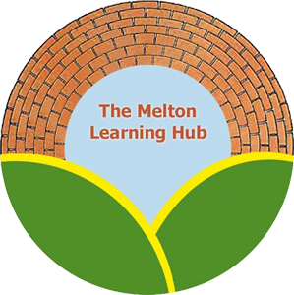

**Transporting your student**

The Melton Learning Hub has been successfully transporting our students from their homes in Leicestershire and Rutland to our sites in Melton Mowbray for the last 8 years.

The transport scheme has a designated driver and inward facing dashcams. They are fully DBS checked, and will be wearing ID badges identifying them as employees of the Melton Learning Hub. In the majority of cases the students will already know them.

We have some rules in our vehicles to ensure a safe journey:

1. We will treat students with courtesy and respect. In turn, we obviously expect students to treat staff, each other and the public with respect.
2. Anyone causing distraction, disruption, damage or bullying can be removed from the transport scheme. Continued problems may result in parents having to pay their own transport provision, in consultation with our providers.
3. We do not allow smoking or vaping in our vehicles, but we also ask that any student does not handle their lighter/matches in the vehicle; we have experienced students playing with lighters in the vehicles causing distraction and, in some cases, damage. We will ask for any lighter/matches taken out in the vehicle to be handed over. We ask for your support with this – they will get it back on arrival. Again, refusal to comply with this may result in The Hub not transporting the student.
4. Students are welcome to listen to their own music, rather than the vehicle radio, but **must** bring ear/headphones. However, we do not allow portable speakers to be used in the vehicles. This is to ensure the driver is not distracted, and can monitor the hands-free phone, and traffic bulletins on the radio.