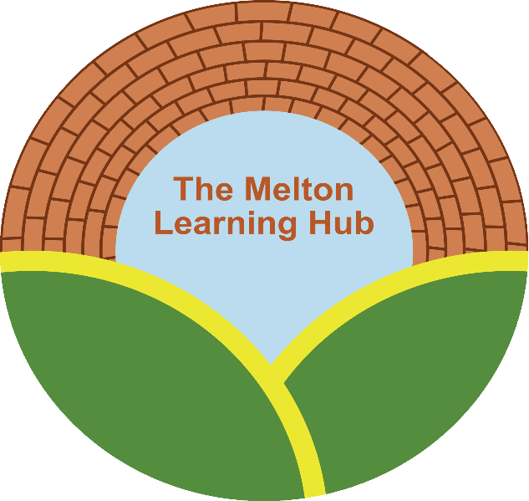

Behaviour Policy

Date policy written/amended/reviewed | Amended/written/reviewed by | Authorised by | Next review due
16.11.16 | Sarah Cox
30/08/18 | Sarah Cox | Sarah Cox | August 2019
June 2019 | Sarah Cox | Sarah Cox | June 2020
June 2020 | Will Andrew |  | June 2021
June 2021 | Sarah Cox | Board of Directors on 8th June 2021 | June 2022
May 2022 | Adie Cox | Board of Directors on 14th June 2022 | June 2023

The Melton Learning Hub is committed to providing a supportive learning environment for young people who have struggled to engage with the national curriculum.
Ethos and Values
Our why
- The right to learn
- Every child is unique and of equal worth
- Through education, every child should be able to achieve their potential and improve their lives and the people around them
Our how
- By shaping our vocational curriculum in a bespoke way using the best skills and knowledge to shape and develop our students long term memory
- Select the knowledge and skills
- Improve the memory
Our what
- Create and deliver an inspirational, knowledge rich vocational curriculum, which is full of best knowledge and skills
- Focus on strategies to develop long term memory
- We have the highest expectations for the culture of our settings and behaviour of the young people
- We create and deliver a package that enables young people to be better humans

We believe that that focusing on the following 5 priorities, we will be to ensure that we deliver our ethos and values successfully to all of our community, especially the most vulnerable.
- Great attendance
- Great belonging
- Great routines
- Great tutoring and learning
- Great community support
In establishing a good routine for learning, this will encourage a feeling of belonging for all of our young people. If they feel that they belong, this will ensure that tutoring and learning will be more effective and in return be better learned and remembered.
It is our duty to prepare our young people to be successful adults, by teaching them the correct behaviours, habits and routines to give them the best possible chance. Respect, kindness and pride are key areas we concentrate on.
Children make decisions focussed on immediate gratification, sometimes this means that they make choices that may not be good for them. We believe it is our responsibility to protect young people from this by enabling them to make good decisions and by supporting them to make these decisions for themselves in the future.

Rewards
Students will be rewarded for good work, attitude and behaviour. Being an Alternative provider this can be more tricky as the basic requirements are not met so through positive re enforcement and encouraging positivity this is improve the application of our young people.
- Reward good behaviour but must be earned over a period of time showing consistency. A reward system is in place and towards end of terms trips out can be awarded for students who show
- Actively build self esteem
- Always follow up on issues
- Work to repair and restore relationships

Good Behaviour and Achievement

Rewards, praise, encouragement and equality are amongst the most powerful aids to learning, maintaining high standards of behaviour and fostering a positive learning ethos.

It is the staff member or tutors responsibility to praise learners where it is deserved. This may be during activities, lessons or at break or lunch showing maturity and being sensible in their free time. Research clearly shows that the most effective positive behaviour modification occur when class sizes do not exceed 4:1 for both learning and behaviour.
These schemes are to motivate students positively in all aspects of learning. Rewards should be given for all of the following
- An excellent piece of work or achievement (relative to the individual)
- Excellent effort
- Good progress
- A positive contribution to the activity
- Consistent good attendance

Types of rewards:
- Verbal praise
- Display of work
- Telephone calls to parent/carer
- Commendation letters/Postcards home
- A stamp on the reward system- 10 stamps will be worth a prize
- Trips out towards the end of term for those students who can be consistent throughout the term

Sanctions

If students at The Melton Learning Hub do not do as required or are doing anything wrong then an incident report will be completed on the day and sent to the Behaviour Manager. From there it will be decided on what action will need to be taken which are as follows:

- Phone call home to parent/ carer
- Phone call to Partnership/ home school
- Letter home
- Lose the chance to be involved in end of term trips
- Exclusion
- Loss of place at The Melton Learning Hub

Sanctions typically work on an incremental basis, allowing students the opportunity to reflect on their behaviour and giving them the chance to improve on their mistakes.

Please see below some examples of this-

A phone-call home would be made for class disruption and refusal to engage in lesson

A letter would be sent home to parent/carer if a student refuses to follow instruction from a Tutor and decides to vape in the classroom area.

Ladder process
We use a ladder process for Exclusions which start with one day, then if something similar happens again would move to three days and final exclusion of five days.

If we reach the end of the ladder then the young person would then lose their place and we could no longer meet need for them. Following any period of exclusion, the young person, member of the Partnership or Parent/ Carer should then attend a Reintegration meeting which will be lead by a member of Management from the Melton Learning Hub. The meeting will happen on the first day of their return before 10am so that they can resume their day once the meeting has been completed.

For instances of extreme violence or damage the centre reserves the right to permanently exclude on a first occasion where we no longer feel we can meet need.

Rules

The basic expectation of all learners
is that you must show respect to other young people, the environment and the staff.

You can do this by following these rules:

- Engage in lessons and activities with enthusiasm and effort
- Help staff if needed with preparation of equipment and resources
- Listen to and follow all instructions
- Work hard and complete the tasks set
- Only leave the room when you are told to do so and don’t disrupt any other lessons that might be happening in the venue
- Accept that each person is different and has their own challenges and we work together to overcome these.
- Vaping can be used by students but parental/carer permission must be needed in order to do so
- Vaping can only take place during break times. It is not permitted at any other time which includes transport home. If this does happen sanctions will be put in place
- The vapes that the young people carry with be their responsibility throughout the day and The Melton Learning Hub will take no responsibility if they become lost or stolen
- The Melton Learning Hub will NOT tolerate any drugs on site or if a young person smells of any type of drug shall be asked immediately to leave site with their Provider and parent/carer being notified on the situation
- Mobile phones, earphones and other related paraphernalia are allowed on site and can be used at break times or if it is agreed with the tutor for research (mobile phone) or if the young person needs time alone to reflect. There should be no other time in the day these items should be out.

Anti-­‐Bullying Policy

MLH policy clearly states that we operate on a zero tolerance basis and that bullying will not be accepted under any circumstances. If a report of bullying is happening it will be notified to management and dealt with accordingly in line with our policy. Sanctions will be put in place and lessons might need to be changed to help the dynamics of the class.

Searching

- School staff can search a pupil for any item if the pupil agrees.
- Behaviour Manager/Centre Manager and staff authorised by them have a statutory power to search pupils or their possessions, without consent, where they have reasonable grounds for suspecting that the pupil may have a prohibited item.

Prohibited items are:
- Knives or weapons
- Alcohol
- Illegal drugs
- Stolen items
- Tobacco and cigarette papers (unless consent given)
- Fireworks
- Pornographic images
- Any article that the member of staff reasonably suspects has been, or is likely to be, used to commit an offence, or to cause personal injury to, or damage to the property of, any person (including the pupil).

- Behaviour Manager/Centre Manager and authorised staff can also search for any item banned by the Provision rules which has been identified in the rules as an item which may be searched for.

Confiscation.
Melton learning Hub staff can seize any prohibited item found as a result of a search. They can also seize any item which they consider harmful to their professional judgement.

Use of reasonable force
There are occasions when the restraint of students is necessary. Staff members trained in physical intervention at the Melton Learning Hub may use reasonable force to prevent learners from:
    - Committing a criminal offence
    - Injuring themselves or others
    - Causing damage to property, including their own property
    - Engaging in any behaviour which has a negative impact on maintaining good order and discipline at the school or on other students

Such physical restraint should only be used in exceptional circumstances, not as a regular or routine act. If restraint has been used a complete report must be sent to the Manager that day. Parents/ carers and home schools will be notified of any restraint used.

