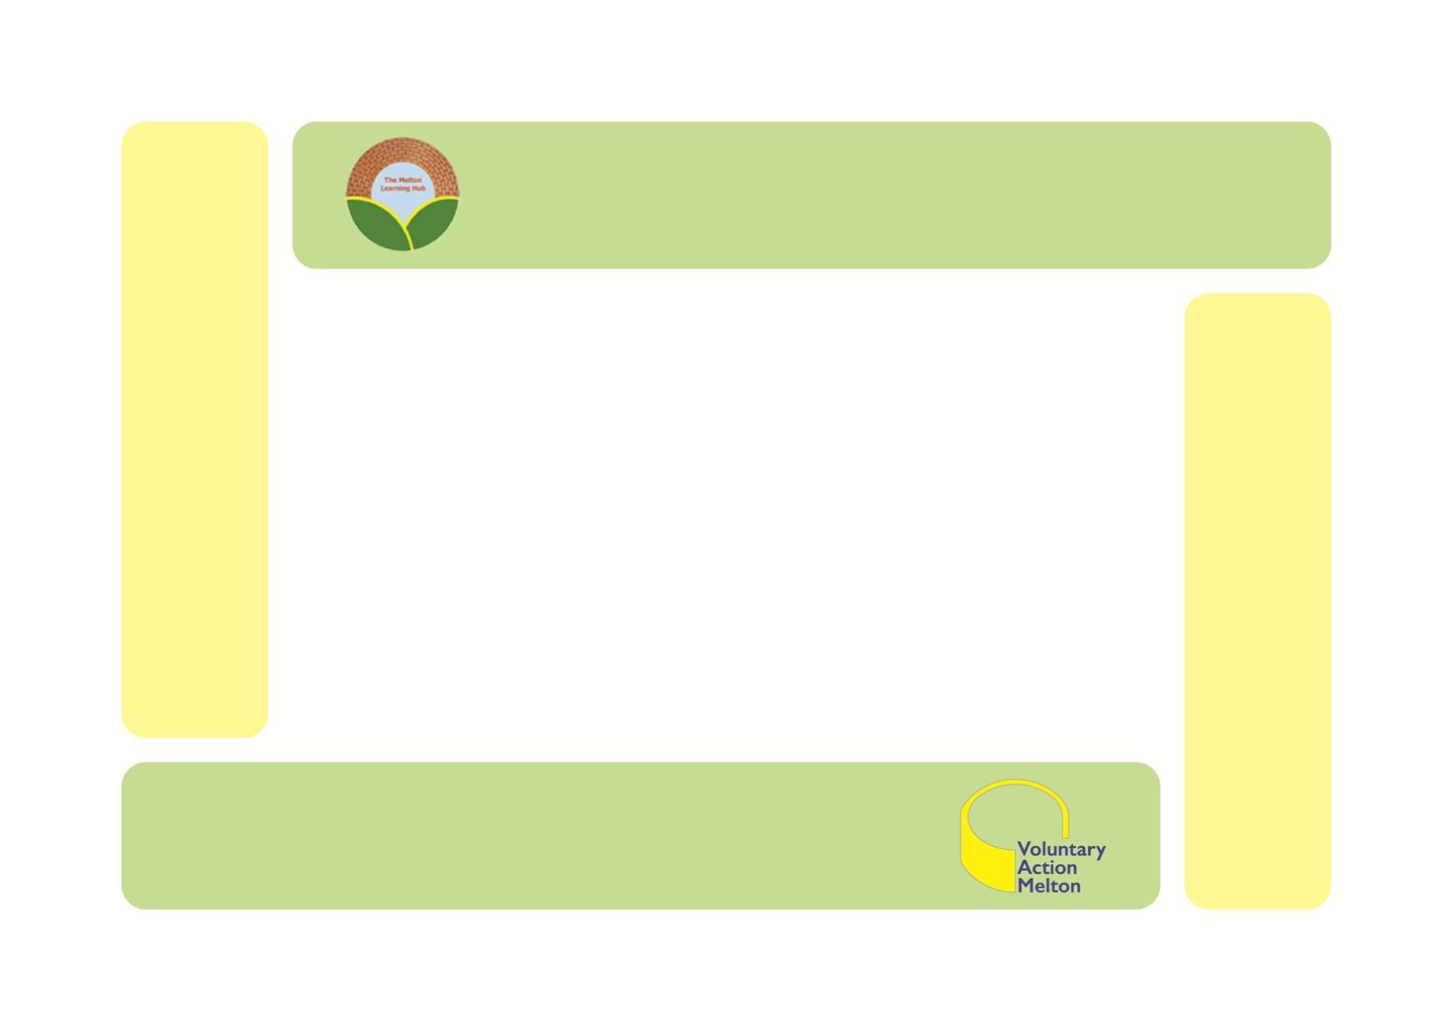

**Melton Learning Hub**

**Annual Report 2020/2021**

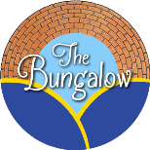

**Melton Learning Hub**

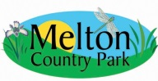

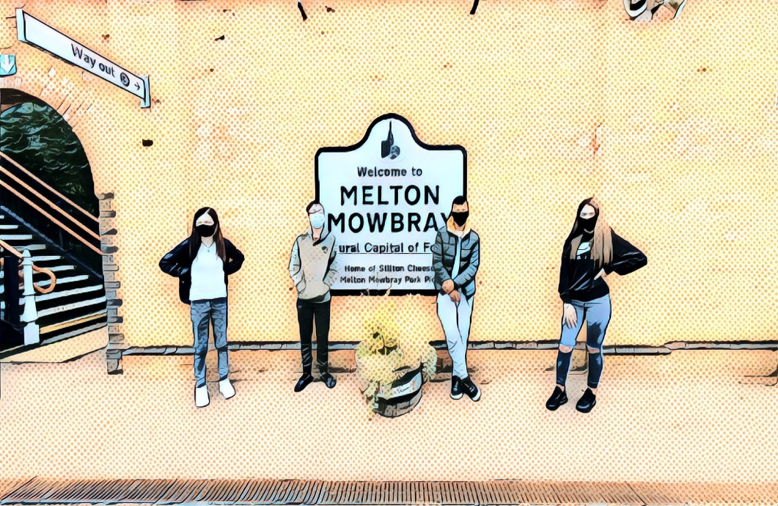

**The Melton Learning Hub**

The Melton Learning Hub (The Hub) is an alternative learning centre, offering young people a variety of vocational qualifications in practical subjects. The joint objectives reflect our combined aims now we have merged with Voluntary Action Melton. Our main objectives are :

(a) To act as a resource for young people up to the age of 25 living in Melton Borough and surrounding areas by providing advice and assistance and organising programmes of physical, educational and other activities as a means of

* Advancing in life and helping young people by developing their skills, capacities and capabilities to enable them to participate in society as independent, mature and responsible individuals.
* Advancing the education of young people
* Relieving unemployment

(b) To help young people, especially but not exclusively, through leisure time activities, so as to develop their capabilities so that they may grow to full maturity as individuals and members of society.

(c) To promote social inclusion for the public benefit in Melton Borough and surrounding areas by preventing people from becoming socially excluded and assisting them to integrate into society.

(d) To develop the capacity and skills of people who are socially excluded in Melton Borough and surrounding areas in such a way that they are better able to identify, and help meet, their needs and to participate more fully in society.

**Registered Office:**

**The Melton Learning Hub**

**Burton Road**

**Melton Mowbray**

**LE13 1DJ**

**Chairperson’s Introduction**

This year has been exceptionally challenging for everyone in our community but for education it has been essential to try and support our students. The centre closed for two weeks to allow staff to make the centre COVID safe. We are proud to say that during the lockdown we continued to support all of our students with an offer of onsite education.

The staff team at the Melton Learning Hub is more than just our educational offer and this year it was a real team effort to run the foodbank. Everyone from Tutors to finance officers worked together to support the community through ensuring the most vulnerable members of our town had a good supply of food. We cherish our role in the community and the foodbank was an exceptional example of how the agencies and community in Melton Mowbray can come together to support each other. A special thank you from the Board and I go out to our volunteer drivers who at one point supported the team to deliver over 250 food parcels a week. We are proud that the distinguished community service of Kev Satchwell was recognised by him being awarded the British Empire Medal in the Queens Honours list.

The support we have received through grants at this time allowed The team to develop agile working with support from the National Lottery to buy laptops. This was supplemented by support from Leicester, Leicestershire and Rutland Community Foundation to extend the provision of laptops so staff were able to set work remotely for students who were isolating. Thanks to Severn Trent who gave us a grant to assist us through any reduction in income during the pandemic.

A special thanks goes to the Rausing Foundation whose grant enabled us to keep our youth centre The Venue and helped us to be ready to run youth clubs as soon as restrictions eased. The year ended with us being able to offer a full summer scheme and it was wonderful for us to again be able to see young people enjoying social and fitness activities due to HAF (holiday Activities Fund).

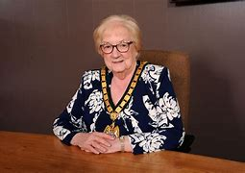

Pam Posnett MBE

Chair of The Board of Directors

**Alternative Education**

Education faced an unprecedented year due to the COVID pandemic. Nothing could have prepared us for the new way of working that would be required. We are especially grateful to the hard work of the team in remaining open throughout the whole of lockdown. The team recognised that we support some of the most vulnerable learners in society and therefore all learners were offered at least 1 day a week face-to-face learning following a 2 week closure to make the building COVID safe. This was accompanied by online learning and hard copies of work being sent home. We even had tutors teaching learners over the phone. I am proud to say that this meant all of our learners did not require predicted grades. All those who worked towards their qualifications, achieved them. This is exceptionally important for our vocational qualifications where learners need the experience of doing the practical work before they progress to apprenticeships and college.

The learners themselves coped really well and many managed to come in and sit their functional skill exams in May and June with an exceptional pass rate. This is commendable due to the time away from class they all experienced and the illness and losses some had within their home lives.

The year was also a challenge in terms of placements. Usually learners are placed with us throughout the year. That was unable to take place and therefore the figures shown represent a significant reduction in numbers based on a normal year. The learners also rose to the challenge during lockdown by preparing a prospectus video for us. This was circulated to all our partner agencies to help future learners see what was on offer at The Hub when visits could not take place.

We encourage you all to look at their work by following the link : <https://www.facebook.com/melton.learninghub/videos/326961235003371>

**Student achievements**

This year we had a reduced number of students due to lockdown and this is reflected in the number of qualifications awarded. A total of 155 qualifications were achieved this year, with the breakdown of subjects and number of achievers shown below:

The most popular qualification remains construction, with 27 learners achieving awards and 16 achieving the harder certificate qualification, which covers more areas of learning, this year. We also have a number of students in-flight ( remain with us for 2 years) who are working towards claiming a certificate next academic year.

. Functional skills level 1 and 2 in Maths and English are the equivalent of GCSEs and give a good foundation for a learner to enter college. Many of the learners who come to the Melton Learning Hub have had a very disrupted early education and therefore achievement at every level needs to be celebrated. Once a student achieves a Level 1 they should be able to write a letter, email , a simple report and complete a presentation for 10 minutes on a subject that is given to them. These are seen as key skills for life and employment. Functional skills can be taken each year so our expectation is that all learners will work towards achieving Entry level 3 or Level 1 by the end of Y11.

**The Venue - Foodbank**

The Melton Learning Hub was proud to work with partner agencies offering a foodbank to our community through lockdown. Our Fareshare membership was invaluable again and through support from grant givers we were able to support a huge number of families. Working with Help the Isolated we increased our reach beyond the figures shown below to families who were assessed to be just above the threshold for financial support. The foodbank was a great example of the strength of our community here in Melton Mowbray with staff from Melton Borough Council and the Melton Learning Hub quickly setting up a system for members of the public to seek and get support where required. All agencies agreed that this level of joint working we hope to take forward in the future for the benefit of the community.

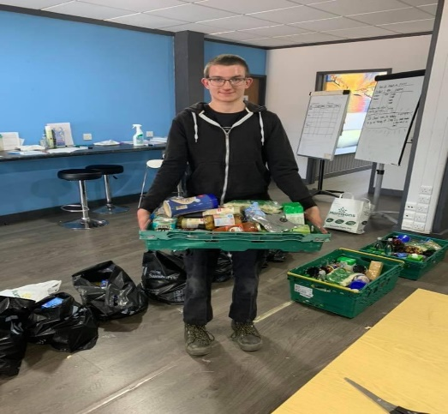

Aaron Isaacs one of our learners who helped with the foodbank and who went on to get a job at his local Tesco store.

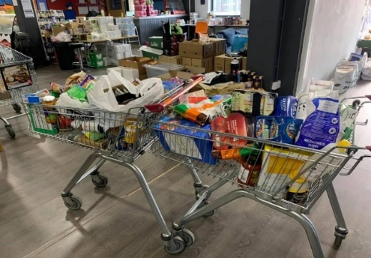 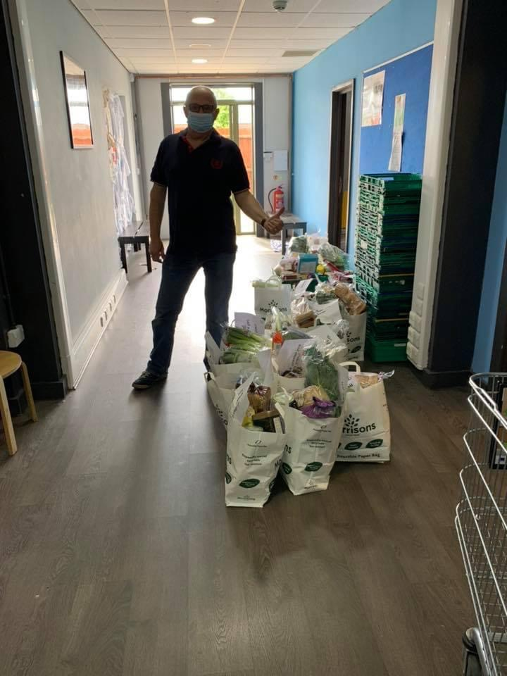

We cannot thank the volunteer driver team enough for their support with the foodbank. Our drivers very quickly moved from transporting vulnerable members of our community to hospital and doctors appointments to delivering food parcels. One driver Kevin Satchwell worked on a daily basis for a number of months supporting the team through lockdown. We are pleased to announce that as a result of his sterling efforts Kevin was awarded the British Empire Medal in the last round of Honours awards.

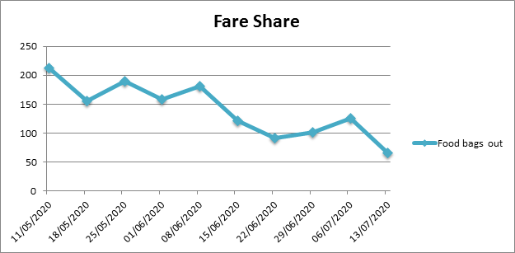

**Youth Club**

Obtaining funding for core youth services is always a challenge. The Melton Learning Hub has run youth clubs from the Venue since 2015. This year we were given a grant by the Leicestershire Police and Crime Commissioner. The grant focused on two groups. The first session ran on a Wednesday evening and worked with young people from across the town to look at knife crime and the impact it can have on their lives. These sessions mixed fun activities with these serious themes.

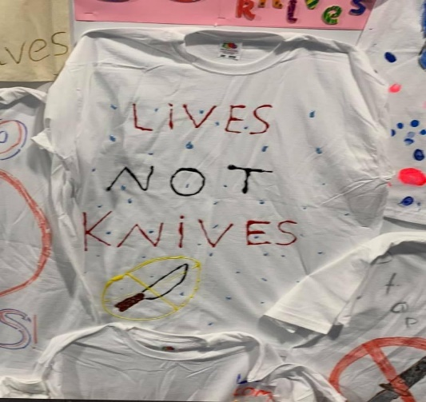



As ever we provided a free hot meal at these sessions each week.

The second session was run by the Engage team (see below for more information on the Engage project). This focused on working with young males who were at risk of offending or were known to carry knives. Although this was a much smaller group it allowed more direct work to take place. During lockdown we could no longer hold face- to-face youth sessions. However, a number of the young people were still managed through our Engage programme.

**Transport Scheme**

The scheme stopped for a short while during total lockdown with the drivers instead supporting the foodbank. We cannot thank enough the volunteers who were keen to support the most vulnerable members of our community return to normal as soon as possible. As soon as we could, introducing facemasks, sanitiser and a cleaning process to all journeys meant they could start again. We now feel we are returning to normal numbers with sessions resuming at Gloucester House and hospital clinics returning to in-person appointments.

**Engage**

We established a partnership with Above and Beyond to create Engage. The project is designed to provide much needed additional support and help for vulnerable young people and their families who are residents of Melton Mowbray and its Borough. These young people are usually at risk of school exclusion, involvement in crime or anti-social behaviour, have poor mental or physical health or have poorer life chances because of poverty or ineffective parenting.

We wanted Engage to reach out to engage and interact with these young people and their families, taking the time and having the patience to seek out creative ideas and activities that could make life a little bit better and easier for them. Part of our core role is to build positive relationships with the young people that enable change to occur.

During our first year we appointed two youth workers, Joe Roughton and Kate Champneys to develop and run Engage. They have laid good foundations that enabled our partnership vision for the project to start to become a reality. We are very successfully reaching the young people that need us and are making a positive difference to them and the Community of Melton. During the second year of the Engage project we have, like all organisations, been significantly hit by the Covid-19 pandemic. Regrettably, it has meant that our school-based groups and diversionary youth groups have had to temporarily close and that has reduced our ability to provide groupwork support.

More successfully we have worked throughout the Pandemic providing support and practical help to all the young people who were referred to us for one-to-one support. We have used a traffic light system to grade the levels of support needed by each individual young person into Red, Amber and Green. Red assessed young people need the most support, followed by Amber and Green. Support was delivered through phone calls, virtual meetings, online lessons and activities, socially distanced outdoor activities, and downloaded lockdown activities from our social media sites. We have successfully managed to maintain all our contacts with young people, and they have seen us work with great determination, persistence, and creativity in supporting them.

Special thanks must go to Kate and Joe for doing such sterling work in such dire circumstances. As we continue to emerge from the Pandemic our third year will see the welcome return of our youth groups, our school-based youth work and face-to-face, one-to-one work. We also hope to meet some new challenges by strengthening our work for post 16-year-olds helping them find employment, training, or further educational opportunities. We will develop some new work around issues that particularly impact on girls and young women. We will also continue to develop and strengthen our emotional, mental, and physical health work with young people.

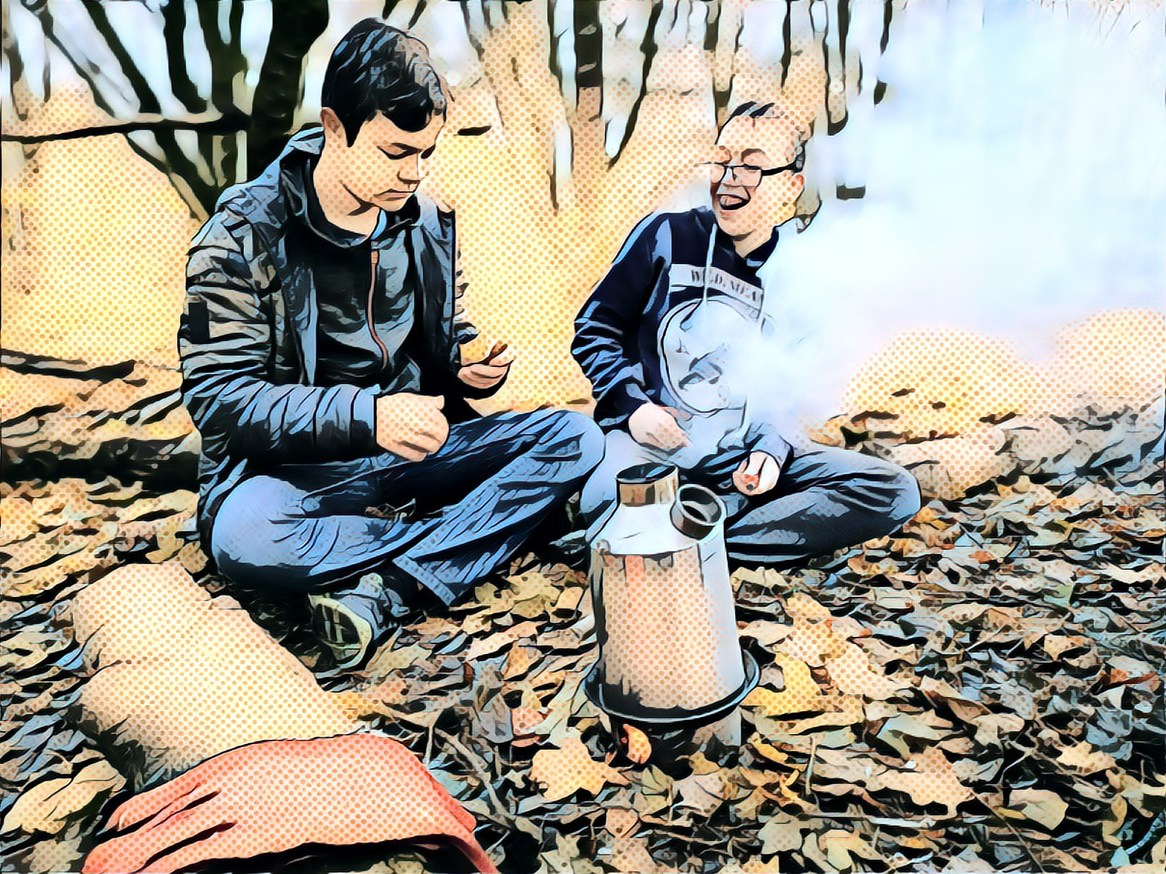

<http://meltonlearninghub.org/wp-content/uploads/2021/12/Engage-Annual-Report-20-21-compressed.pdf>

**HAF Summer Scheme**

As the lockdown eased and we approached summer, The Melton Learning Hub was awarded funding from the Holiday Activities Scheme. We were able to offer 30 places to children in receipt of free schools meals from across the district of Melton Mowbray. For 4 weeks the children came to the centre and took part in fitness, craft and healthy eating activities. Thank you to Morrison’s, and in particular Rob Moorish, who came and did a presentation on fruit and the air miles of our food. The Melton Learning Hub was also able to fund a trip for 30 children to Planet Bounce.

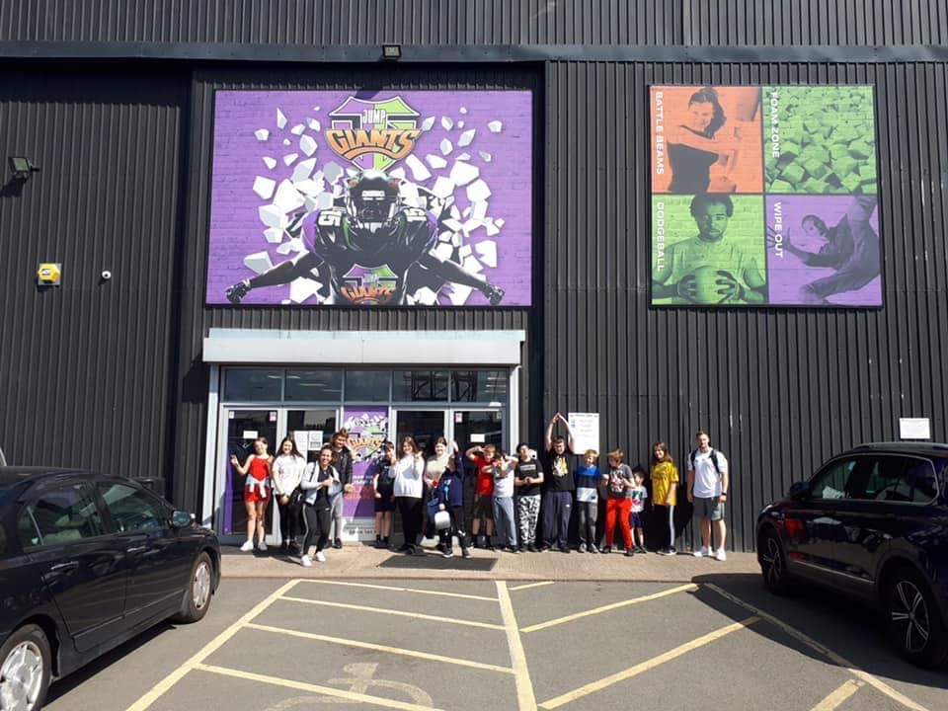

**Trustee statement**

The Melton Learning Hub is a company limited by guarantee governed by its memorandum and Articles of Association. It is a registered charity with the Charity Commission.

Its main purpose is to promote charitable purposes for the benefit of the community and is contracted to act as a community hub, providing a range of services directly to the community.

There were 9 trustees at the start of the financial year, each of whom agrees to contribute £10 in the event of the Charity winding up.

**The Melton Learning Hub Trust Board and Company Directors**

Pam Posnett - Individual Member - Chairperson

Jane Horn - Individual Member

Kate Theobald - Individual Member

Linda Moore – Individual Member

Steve Taylor – Vice Chair

Peter Treadwell - Individual member

Rob Whittingham - Individual member

Doug Clements - Individual member

Sharon Brown - Individual member

**Thank You to our Funders**

The Melton Learning Hub is extremely grateful to the following funding bodies who have helped and supported its work through the year:

* The Leicester, Leicestershire and Rutland Community Foundation.
* Transport Project - Leicestershire County Council
* Children in Need
* Seven Trent
* All three Melton Rotary Clubs: The Melton Club, Aurora & Belvoir Clubs
* National Lottery Community Fund
* Ragdale
* Your Shire Community Grant
* Leicester Fire and Rescue Service
* Aston Vauxhall
* The Rausing Foundation

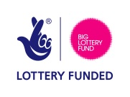

**Operational and Financial Statement**

The Melton Learning Hub continues to operate a sound financial accounting system in accordance with its status as a charity (1139747)

Despite the ever-challenging financial climate that charities are facing, our Charity remains in a sustainable position. The focus of the Charity’s financial position is to reduce the requirement for external funding and to ensure that all areas of operation are self-sustaining.

A copy of our year end accounts will be published on our website.

Helen Simpson

Finance Manager

**Bankers HSBC Melton Mowbray**

**Auditors TC Accounts**

99 Chapel St,

Ibstock,

Leicestershire

LE67 6HF