Challenge 1: Active Bingo  How many of the activities can you complete from the bingo card in your activity pack?  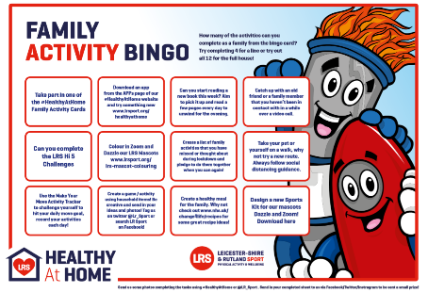 | Challenge 2: Outdoor Games  Use the skipping rope and frisbee (found in your activity pack) in an open space. How many jumps can you do in 30 seconds with the skipping rope? How many passes can you do the frisbee? What other games can you think of to play with these?
Challenge 3: Family Challenge  Decide on an activity to try as a family. What activities would be fun to try? Don’t worry if you are struggling for ideas, the Physical Activity Officer will be able to help you! Write what you tried below: | Challenge 4: Hi Five Challenge  Try the New Age Kurling Challenge. What’s the highest score you can get with your stones?  https://www.lrsport.org/hifive-challenges  Write your top scores in the stars below.
Challenge 5: Send us a Postcard  In your activity packs you will find a postcard asking you what you have enjoyed about the activity pack. Complete the post-card and if possible, please send back to you, we would love to hear from you. | Well Done!  Thank you for completing the physical activity challenges over the last few weeks. We hope that you continue to enjoy being active as a family.  For more information on staying active visit:  www.lrsport.org
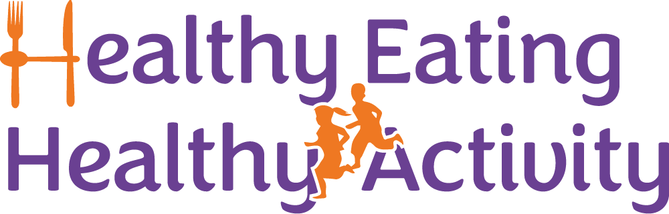
Partnership Working between Active Together , Leicestershire County Council, Blaby District Council, Charnwood Borough Council, Harborough District Council, Hinckley & Bosworth Borough Council, Melton Borough Council, North West Leicestershire District Council and Oadby & Wigston Borough Council.
A Physical Activity Officer will ring you during the week to see how you are getting on with your activity challenges. They will be able to talk to you about the activities on this card and tell you about local opportunities to be active near you.
Welcome to your Moving More Challenges for Week 8.
We would like to you try all of the challenges as a family over the next week.

