Challenge 1: Zoom’s Zig Zag’s  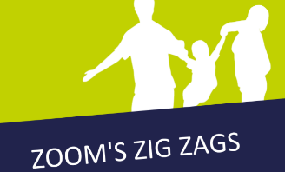  Fly like a rocket and move between the planets to get active in outer space. You could run, skip, jump or crawl your way through to make it super-exciting.  Find the instructions in your activity pack. | Challenge 2: Target Bowling Challenge  Set your self a distance to bowl from and set up a target (wicket) to aim at. Hope many points can you score in an over of bowling?  Over of Bowling = 6 bowls  Hitting the wickets = 6 points
Challenge 3: Online Activity Session  Why not try out one of the online activity sessions such as Disney Dance Workouts, Yoga? Find online classes at the links below. Which one did you try?  https://www.lrsport.org/children-and-families  https://www.sportengland.org/jointhemovement | Challenge 4: Hi Five Challenge  Have a go at the 30 second shot challenge. How many shots can you make in 30 seconds?  https://www.lrsport.org/hifive-challenges  Write your top scores in the stars below.  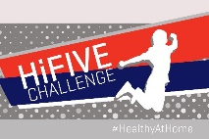
Challenge 5: Family Challenge  Decide on an activity to try as a family. What activities would be fun to try? Don’t worry if you are struggling for ideas, the Physical Activity Officer will be able to help you! Write what you tried below: | Did You Know?  Did you know that “feel good” chemicals are released by the brain during exercise and helps to improve your mood.
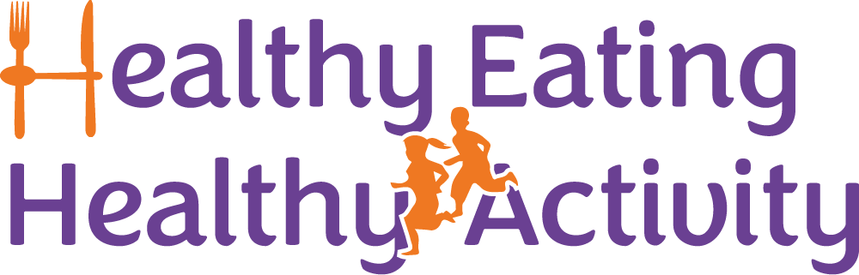
Partnership Working between Active Together, Leicestershire County Council, Blaby District Council, Charnwood Borough Council, Harborough District Council, Hinckley & Bosworth Borough Council, Melton Borough Council, North West Leicestershire District Council and Oadby & Wigston Borough Council.
A Physical Activity Officer will ring you during the week to see how you are getting on with your activity challenges. They will be able to talk to you about the activities on this card and tell you about local opportunities to be active near you.
Welcome to your Moving More Challenges for Week 6.
We would like to you try all of the challenges as a family over the next week.

