Challenge 1: Animal Charades  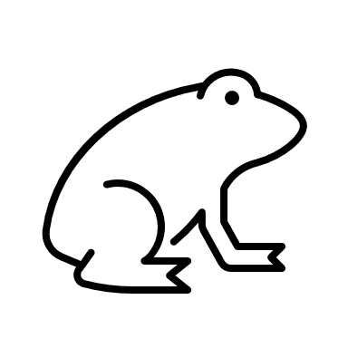  Take it in turns to act out the movements of an animal (it can be more fun if you add sounds too!).Alternatively, act out your favourite film, TV show or book.  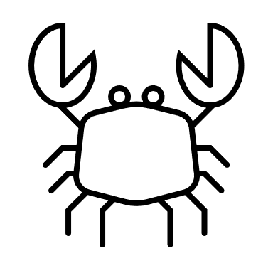 | Challenge 2: Rainbow Target Throw  Colour in or label 7 different pieces of paper (the colours of the rainbow). Stick the paper on the wall with red being the highest and violet the lowest. Take 4 steps back and mark out a throwing line. Grab a soft ball (or rolled up socks) and see if you can hit all the colour in order. How many attempts does it take?
Challenge 3: Dice Challenge  Either make a dice out of a cardboard box, or use a dice that you might have at home.  Make a list of 6 exercises e.g. 1 = 20 jumping jacks, 2 = 15 sit ups etc.  Roll the dice and do the exercise! | Challenge 4: Hi Five Challenge  Try the Bat and Ball challenge, how many times can you keep the ball up with the bat?  https://www.lrsport.org/hifive-challenges  Write your top scores in the stars below.
Challenge 5: Family Challenge  Decide on an activity to try as a family. What activities would be fun to try? Don’t worry if you are struggling for ideas, the Physical Activity Officer will be able to help you! Write what you tried below: | Did You Know?  Everything counts! It doesn’t matter what you do to get moving, as long as you are moving more! It all counts, so make moving fun and do what you enjoy.
Partnership Working between Active Together, Leicestershire County Council, Blaby District Council, Charnwood Borough Council, Harborough District Council, Hinckley & Bosworth Borough Council, Melton Borough Council, North West Leicestershire District Council and Oadby & Wigston Borough Council.
A Physical Activity Officer will ring you during the week to see how you are getting on with your activity challenges. They will be able to talk to you about the activities on this card and tell you about local opportunities to be active near you.
Welcome to your Moving More Challenges for Week 3.
We would like to you try all of the challenges as a family over the next week.

