Challenge 1: Make Your Move  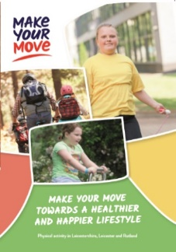  Read the Make Your Move  Booklet and complete  the activities inside. | Challenge 2: Activity Tracker  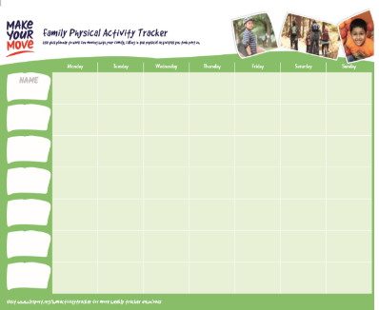  Stick the Family  Activity Tracker  on a wall and  use it record how  much activity you  do over the week.
Challenge 3: Family Game  As a family why not play “The Bean Game”. All instructions can be found in your activity pack.  Which action is your favourite? | Challenge 4: Hi Five Challenge  Have a go at the Target Throw Challenge, how many targets can you get in the basket in 30 seconds?  https://www.lrsport.org/hifive-challenges  Write your top scores in the stars below.
Challenge 5: Family Challenge  Decide on an activity to try as a family. What activities would be fun to try? Don’t worry if you are struggling for ideas, the Physical Activity Officer will be able to help you! Write what you tried below: | Did You Know?  Children and Young People should aim to be active for an average of 60 minutes a day and adults 150 minutes a week?
Partnership Working between Active Together, Leicestershire County Council, Blaby District Council, Charnwood Borough Council, Harborough District Council, Hinckley & Bosworth Borough Council, Melton Borough Council, North West Leicestershire District Council and Oadby & Wigston Borough Council.
A Physical Activity Officer will ring you during the week to see how you are getting on with your activity challenges. They will be able to talk to you about the activities on this card and tell you about local opportunities to be active near you.
Welcome to your Moving More Challenges for Week 1.
We would like to you try all of the challenges as a family over the next week.

