Melton Learning Hub
Annual Report 2018/19

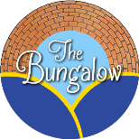

Melton Learning Hub

The Melton Learning Hub
The Melton Learning Hub (The Hub) is an alternative learning centre, offering young people a variety of vocational qualifications in practical subjects. The joint objectives reflect our combined aims now we have merged with Voluntary Action Melton. Our main objectives are:
(a) To act as a resource for young people up to the age of 25 living in Melton Borough and surrounding areas by providing advice and assistance and organising programmes of physical, educational and other activities as a means of:
- Advancing in life and helping young people by developing their skills, capacities, and capabilities to enable them to participate in society as independent, mature and responsible individuals.
- Advancing the education of young people
- Relieving unemployment
(b) To help young people, especially but not exclusively, through leisure time activities, so as to develop their capabilities so that they may grow to full maturity as individuals and members of society.
(c) To promote social inclusion for the public benefit in Melton Borough and surrounding areas by preventing people from becoming socially excluded and assisting them to integrate into society.
(d) To develop the capacity and skills of people who are socially excluded in Melton Borough and surrounding areas in such a way that they are better able to identify, and help meet, their needs and to participate more fully in society.

Registered Office:
The Melton Learning Hub
Burton Road
Melton Mowbray
LE131DJ

Chairperson’s Introduction
It is always with a sense of pride that I write the introduction to this annual report
(2018-19). The need for the services that The Melton Learning Hub and Voluntary Action Melton offer continues to rise in very challenging financial times. Our staff have to be ever resourceful to find the means to meet those needs. The importance of multi-agency partnership working is central to our success, and although still in the first phase Engage is an excellent example of a community identifying a need and working together. As well as our funding partners listed elsewhere in this report, I should like to thank, on behalf of the directors, our dedicated and hardworking staff team who make all this happen. Melton borough is a better place as a result.
Pam Posnett
Chair of board of Directors
Alternative Education
The past year has been a challenging environment for alternative education centres as funding to schools was affected by national austerity, this in turn influenced the number of placements to alternative centres such as ours. The approach taken by the team has been to offer a broad range of qualifications to support all learners. It is believed this variety has enabled the Hub to remain buoyant in these challenging financial times.
The Progress 8 offer remains however for the next academic year. All qualifications will require learners to sit an exam, we know this is going to provide difficult for many of our learners.
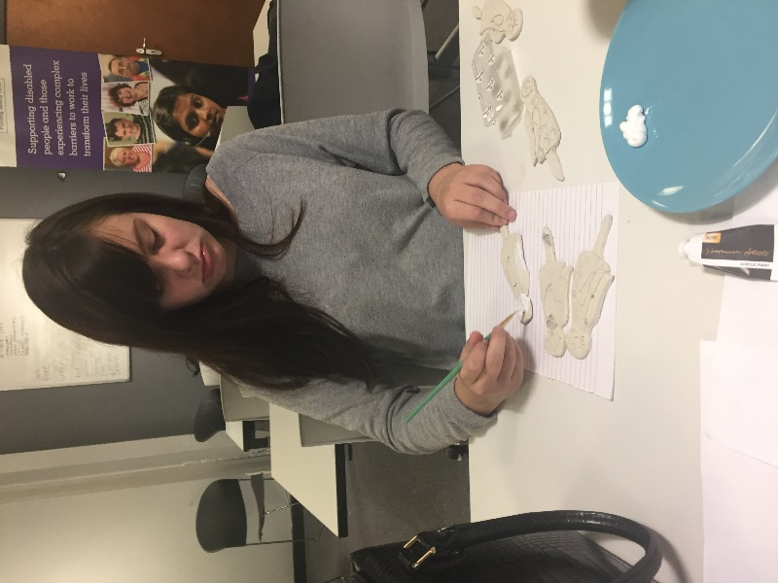
Jorja Ryles who achieve a Level 1 Merit in Creative Craft.

Learners have continued to achieve a broad spectrum of qualifications as illustrated in the charts below.
Qualifications
Learners Attending The Hub 2018-2019 Total learners 171
We have had 171 learners pass through our doors for the academic year 2018/2019. Not all these students stayed for a full academic year or attended for full days. Of the students that did complete the full year 119 qualifications were achieved. A number of learners are now on larger courses which run over two years.

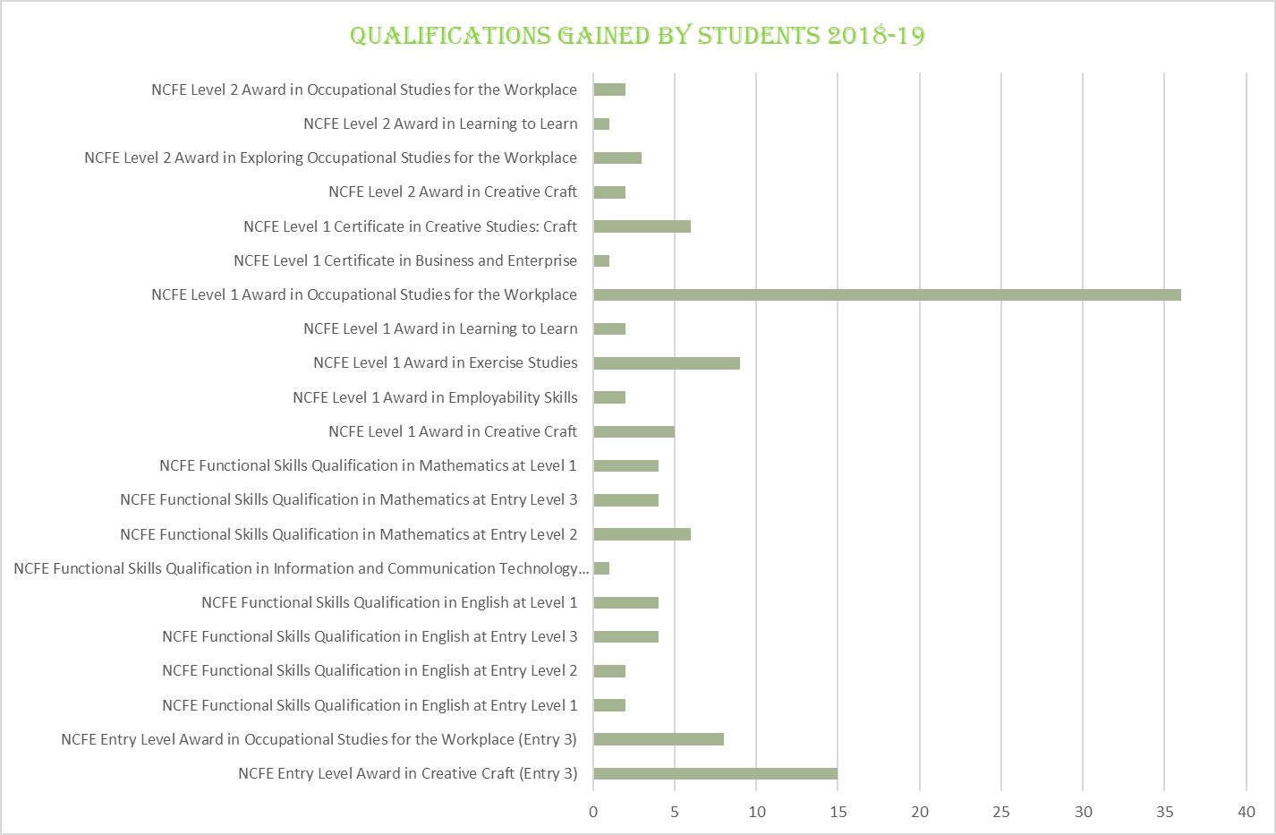

Finance and Funding
The charity remains in a financially secure position with the majority of all income being spend on direct service delivery by staff for all areas of the charity. The financial stability of the charity is supported by the funding received each year and this continues to be an important source of income.
Student travel only accounts for 5% of the income generated by the charity, however it has secured contracts for learners from the Rutland area. It has also notably improved attendance of the learners at centre.
The core funding for the transport scheme remained fixed for 2018/2019 as this was the last year of planned cuts by Leicestershire County Council. In this environment it is a positive that the charity made a small profit and can look to fund repairs at both sites it operates from.
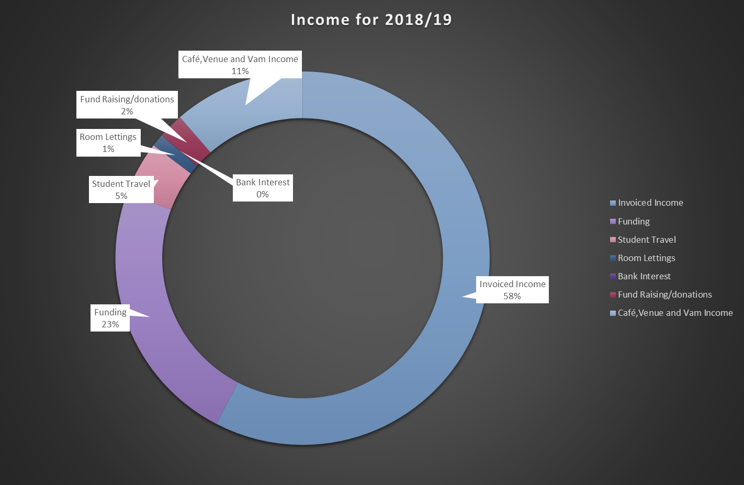
Breakdown of Income for The Melton Learning Hub 2018-2019

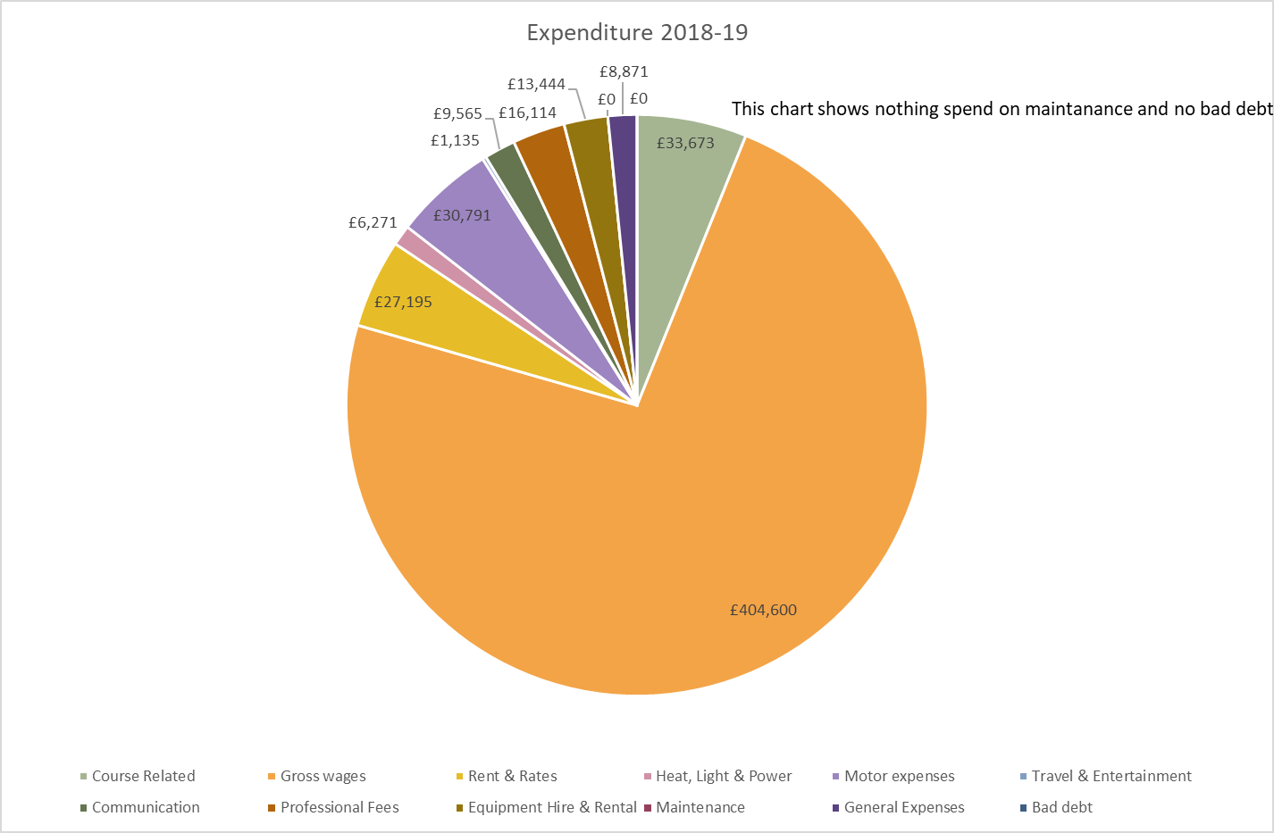
Breakdown of Expenditure for The Melton Learning Hub 2018-2019
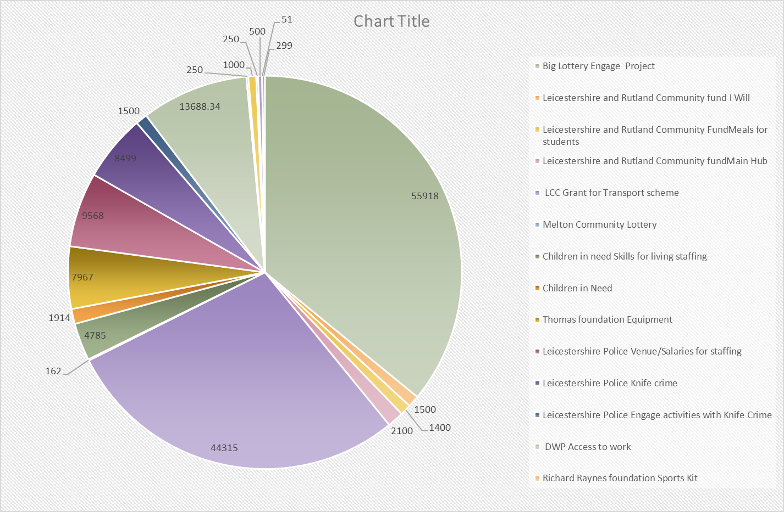
Breakdown of Funding obtained by the Melton Learning Hub 2018-2019

Children In Need
Through the small grants programme the Melton Learning Hub was granted funds for a three-year project to support learners in developing independent skills for living. The project focuses on managing a budget, eating healthily, equipping a flat with essentials as well as other life skills. The course has proved popular and helped around 40 young people in the first year. In the second year we intend to develop the course to offer internet safety and managing finance on the internet. We recognised that for the younger generations many of their bills and finance transactions will be online and to do this safely will always be a challenge.

Engage
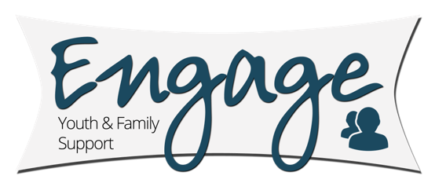
The Hub constantly aims to improve the lives of young people in Melton Mowbray both in the services it offers but also with partner agency schemes. This year we were successful in our bid to the National Lottery for the creation of the Engage project. The project funds two full –time Youth and Family Support Workers based at The Venue. The scheme was funded to support 11-16-year olds however through supplementary funds from the Your Shires Grant we have been able to extend the service to 16-25-year olds.

The sessions involve the workers establishing, building, maintaining a professional guiding and educative relationships with the refereed young people. Sessions involve leisure, recreational and education activities. The workers have developed a wide range of activities that will enable the young people to build their personal resilience and establish for themselves a positive and better future. Sessions also address issues such has anger, bereavement, anxiety, poor social skills, low self-confidence.
For the project, The Melton Learning Hub is working in partnership with Above and Beyond, who are a youth and community registered CIC. Based in Leicestershire they have a small number of professionally qualified paid youth workers who do one to one personal and social development work with vulnerable young people. They began working in the Melton Borough in 2016, offering support to teenagers who were finding life difficult, or were vulnerable by their own poor life choices.
Above and Beyond already work closely with The Melton Learning Hub and the Melton Behaviour Partnership with a small number of funded young people. They offer specialist work around violence/aggression/substance misuse/family problems and low-level mental health issues.
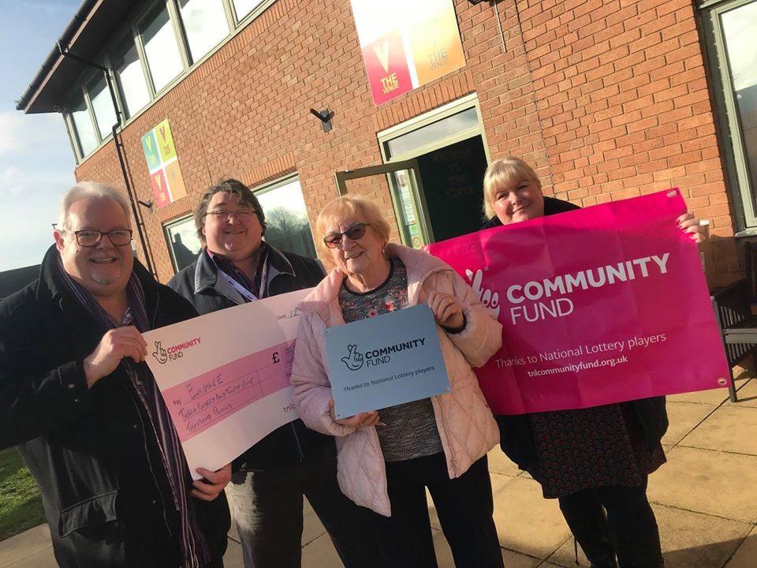
From Left to Right Andrew Lake and Colin Laws (Above and Beyond) Cllr Pam Posnett MBE and Sarah Cox (The Melton Learning Hub)

Together we knew that we could provide a service for referred young people which was different to what other agencies provide. Many of the young people have already had numerous professionals in their lives, so we needed to offer something different.
They have to work with all the other adults in their lives – teachers, social workers etc – they choose to work with us. This is what we wanted to extend, develop and build upon, together with The Melton Learning Hubs expertise in education.
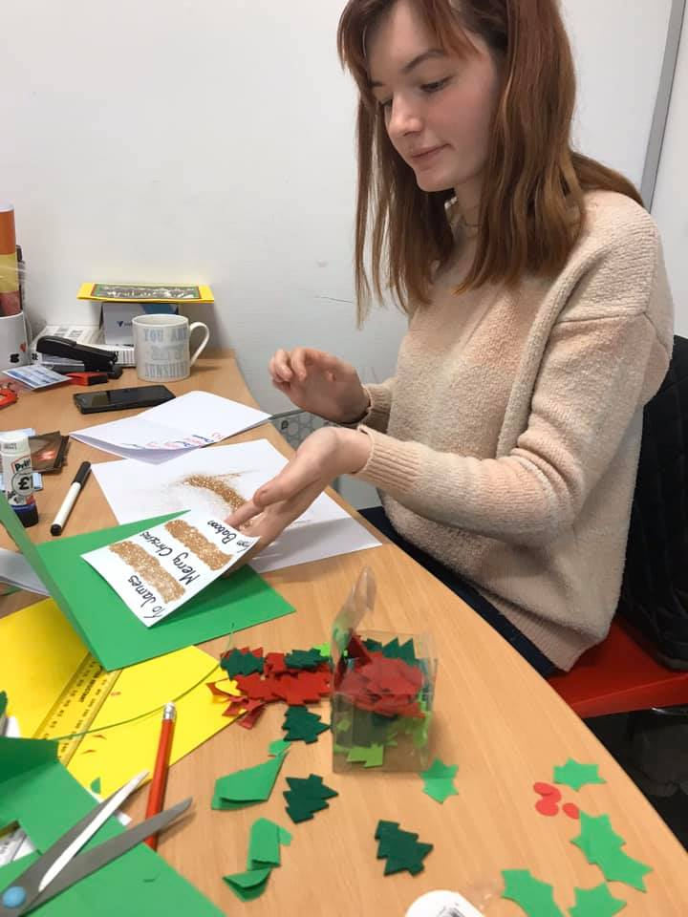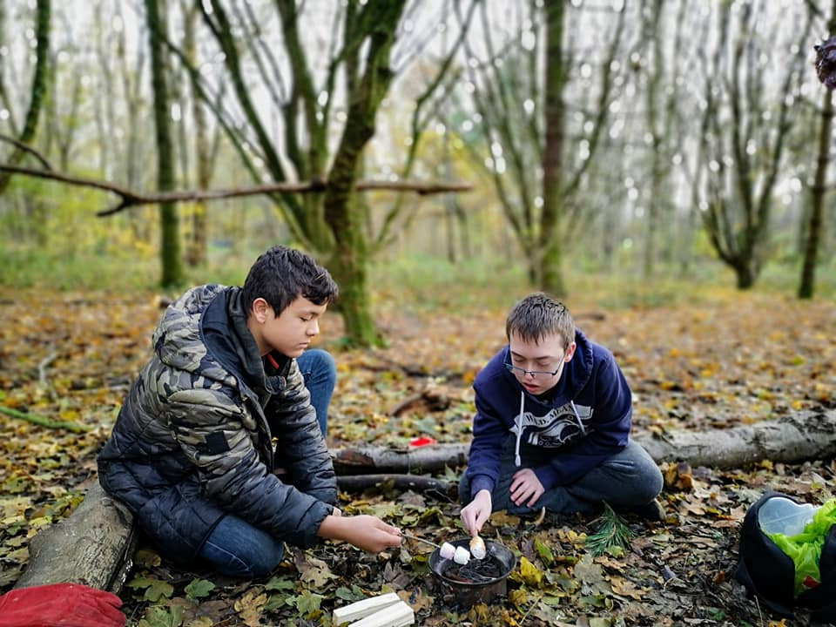
Just some of the activities young people complete as part of the Engage programme.

Through our work together we have seen the success of a holistic approach with young people and their families and the project has allowed the scheme to support families and young people across the district of Melton Mowbray.

Two Youth Support Workers are based at The Venue; this was identified by local young people and their families as the place they consider safe. The feedback we had was that The Venue was “theirs”.
Joe Roughton Kate Champney

The two workers were appointed in March 2019. Referrals into the service can be made by anyone. Throughout the year sessions have expanded. Group work is being conducted in both Longfield Academy and John Ferneley College. For young people requiring more support one to one sessions are offered. We look forward to the second year and further development and evaluation of the work being done.

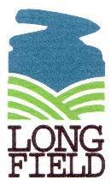

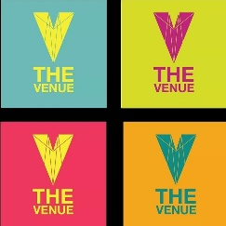
The Venue
When the funding for The Venue ceased there was a lot of concern from local parents about the loss of the youth sessions locally. The sessions were seen as a safe place for young people to socialise and have fun. The key cost of the sessions was staffing and recognising the importance placed on the sessions the board of Directors for the Melton Learning Hub took the decision to fund the continuation of the sessions whilst alternative funding was sought. We were pleased to announce that with the support of our local police additional funding was awarded by the Police and Crime Commissioner Lord Willy Bach to continue with some of the sessions.
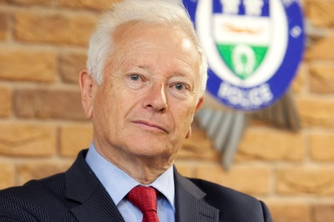
Lord Willy Bach- Leicestershire Police and Crime Commissioner

Every Wednesday 46 weeks of the year a free session is offered to young people aged 11-16yrs. The sessions start at 4.30pm until 6pm. The sessions run activities but also run educational sessions on such themes as knife crime and first aid.
This combination of fun and learning is working well with sessions being attended by over 35 children each week.
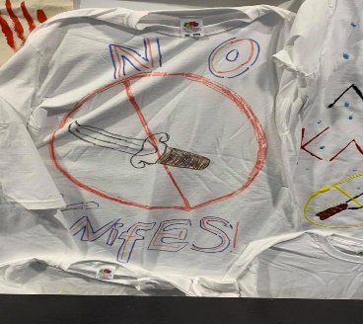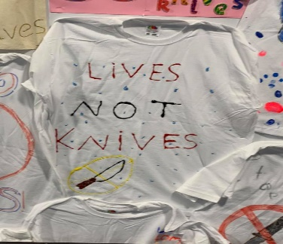
Just some of the items made by young people during an anti-knife crime workshop
The Venue also offers a targeted session for young people on the cusp of offending and this session is supported by the Engage workers.
Leicestershire Holiday Activities & Food Programme
In the summer of 2019, the government announced plans to offer clubs, charities and schools the opportunity to run free school holiday sessions for young people in receipt of free school meals. The process was co-ordinated by Barnardos and invites were sent out to all charities. Each centre had to aim to offer 4 weeks of provision for 4 days a week and 4 hours a day. The Melton Learning Hub was approached to offer this provision. We recognised that this could not be done alone, so in the tradition of multi- agency working partners came together from across the district to see how we could offer this programme to as many young people as possible.
Partners involved were: John Ferneley College; Longfield Academy; Melton Borough Council; Leicestershire & Rutland Sport; Engage and all the teaching staff of The Melton Learning Hub.
Together we were able to offer the full 4-week provision, welcoming around 30 young people each day. Each day a craft and sporting activity was delivered by one of the partner agencies. Through our partnership with Fareshare we were also able to offer free breakfast and lunch to all young people attending.
Recognising that a broad spectrum of families struggle during the Summer holidays the scheme was not only offered to those on Free School meals but to all young people who wanted to attend. The multi-agency team felt that this approach did not stigmatise and was in the spirit of what all agencies wanted to deliver.
The funding we obtained for the scheme was used to purchase a large amount of sports equipment that can be used by all agencies and to fund a free trip to Planet bounce for the whole group.
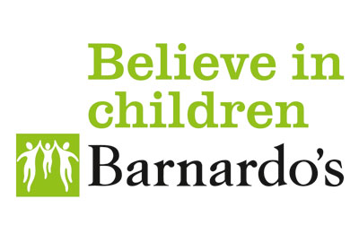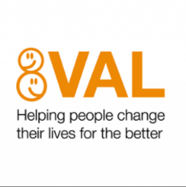
Transport Scheme.
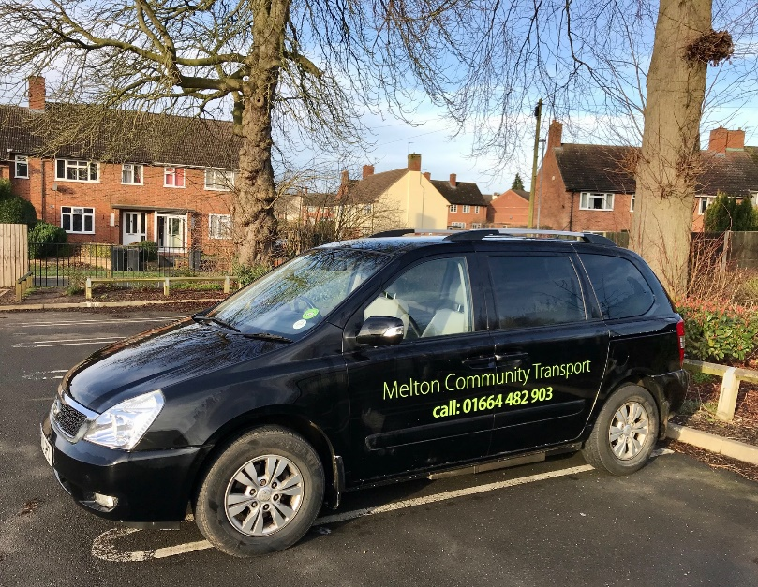
The transport scheme operates from The Venue. The scheme has three part-time members of staff but is supported by 21 volunteer drivers. Over the past year the scheme has completed 8182 passenger journeys, supporting vulnerable members of our community who cannot drive or access public transport.
The scheme supports different types of journeys. The largest group is supporting people to do the following: day centre attendance, lunch clubs, shopping, hairdressers, day hospice attendance, medical, dental and optician appointments. 6563 journeys fell into this category with 581 journeys requiring wheelchair transport.
The second group of journeys are to hospital, the scheme completed 1577 journeys in this category this year.
Personal quote.
“I recently moved to Melton Mowbray to live with my daughter. I regularly need to go to hospital and the volunteer drivers have been wonderful in getting me to the Leicester Royal Infirmary. They often wait for me. I cannot thank them enough. I had a regular driver and we shared an interest in horseracing, so the journeys were full of top tips.” Michael Vinnicombe service user.
We also maintain a minibus which is available for community group use. Over the last year the following groups have been able to go on trips with the support of our volunteer drivers:
Evergreen Group
Advance
Mencap
Scalford W.I.
Waltham W.I.
Melton W.I.
Scalford Court
Sage Cross Church
St.Mary’s C of E Primary School
Despite the austerity challenges faced by all local authorities the good news is that Leicestershire County Council have confirmed they will continue to support the local voluntary transport schemes ensuring their future for the coming year.
Future Year
2020 will see us launch into the second year of the Engage project. It will also allow us to fully evaluate the data and feedback from year 1. Services users might see some refinements to the scheme as we hope to further develop our services to meet demand.
The transport scheme also run a community minibus which is regularly used by charities and groups from across the district. The minibus is now some 17 years old and despite love and care is getting a little tired. We hope to launch a fundraising event in 2020 to ensure this valuable resource is maintained for the wider community.
The Progress 8 requirements introduced by the Department of Education seek to improve the quality and level of education achieved by all Key stage 4 students. The movement away from coursework to more exam-based subjects has been part of this process.
For many of our learners’ exams are particularly challenging, especially when many have accompanying special educational and welfare needs. The Melton Learning Hub will always support learners to achieve their potential and recognise that Progress 8 is part of this requirement to support their transition to the workplace. We do however remain committed to supporting all learners whatever their academic levels with the goal of making them college or work ready and therefore will continue to offer a variety of vocational qualifications outside of the Progress 8 model.
Trustee statement
The Melton Learning Hub is a company limited by guarantee governed by its memorandum and Articles of Association. It is a registered charity with the charity Commission.
Its main purpose is to promote charitable purposes for the benefit of the community and is contracted to act as a community hub providing a range of services directly to the community.
There were 10 trustees at the start of the financial year (April 2016) each of whom agrees to contribute £10 in the event of the charity winding up.

The Melton Learning Hub Trust Board and Company Directors
Pam Posnett - Individual Member-Chairperson
Jane Horn- Individual Member
Keith Aubrey- Individual Member
Kate Theobald- Individual Member
Linda Moore – Individual Member
Steve Taylor – Individual Member
Diane Featherstone – Individual Member
Sarah Andrew- Individual Member
Peter Treadwell- Individual Member
Thank You to our Funders
The Melton Learning Hub is extremely grateful to the following funding bodies who have helped and supported its work through the year:
- The Leicester, Leicestershire and Rutland Community Foundation.
- Transport Project- Leicestershire County Council
- The Masonic Association
- Children In Need
- All three Melton Rotary Clubs: The Melton Club, Aurora & Belvoir Clubs
- Big Lottery
- Ragdale Hall
- Your Shire Community Grant
- Leicester Fire and Rescue Service
Operational and Financial Statement
The Melton Learning Hub continues to operate a sound financial accounting system in accordance with its status as a charity (1139747)
Despite the ever-challenging financial climate that charities are facing the charity remains in a sustainable position. The focus of the charities financial position is to reduce the requirement for external funding and to ensure that all areas of operation are self-sustaining.
A copy of our year end accounts will be published on our website.
Helen Simpson
Finance Manager
Bankers HSBC Melton Mowbray
Auditors TC accounts
Harwood House
Park Road
Melton Mowbray
Leicestershire

