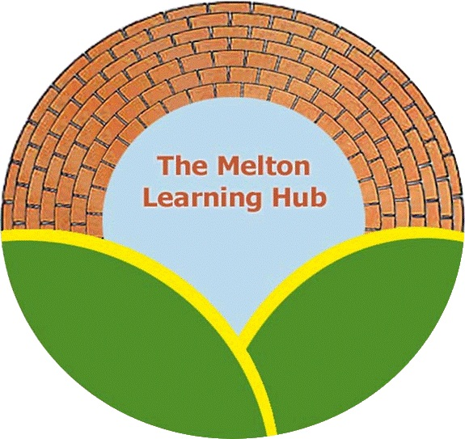

Policy Review Record

This policy relates to all premises under the governance of the Melton Learning Hub social enterprise whilst being used for educational purposes.

Policy Name: Drug Use Policy

Date policy written/amended | Amended/written by | Authorised by | Next review due
21st July 2015 | Sarah Cox
August 2018 | Sarah Cox | Sarah Cox | August 2019
June 2019 | Sarah Cox | Sarah Cox | June 2020
June 2020 | Sarah Cox | Sarah Cox | June 2021

POLICY FOR DEALING WITH DRUG USE AT THE MELTON LEARNING HUB

This policy has been written to help staff at the Melton Learning Hub deal with students who appear to be under the influence of drugs. The following steps should be taken before action is taken by the Managing Director, Operations Manager or Lead Tutor. The immediate welfare of the child is of priority and the approach taken by staff should be of welfare support, intervention and education. This policy only relates to facilities within the Melton Learning Hub where educational classes are taking place. A separate policy may exist for The Venue and Country Park café when open for the use of the public.
The Hub’s management team will do their best to ensure all staff members take part in suitable substance misuse awareness training events. This will help the staff members to recognise the signs and symptoms of drug use.
- First instance: If the use of drugs is suspected ,the member of staff should alert other team members and separate the young person from the rest of the group. Establish if the young person requires medical attention. Discuss with them what drug they have taken and when.
- Removal from certain lessons- A young person believed to be under the influence might not be able to continue within their class. The tutor for the class should conduct a dynamic risk assessment according to planned activities and identify to the Director or the Operations Manager if the young person is unable to continue in the class. The young person cannot continue with any activity which could be a danger to themselves or others. If the young person is unfit to continue with any form of education the child’s parent or carer and education provider, should be contacted and then sent home.
- Drug use not permitted on site, we acknowledge some students might be drug dependant and we wish to support them remaining in education however we cannot allow other students to be influenced by individual behaviour. We aim to work with young people to overcome their drug habit and therefore initial action will be supportive in nature.
- All cases create a drug incident sheet. Noting the demeanour and response from the young person. A letter should be drafted to the carer of the young person identifying that we believe the young person to have taken drugs and invite the carer to discuss a plan to address this with the Managing Director Operations manager or the Lead Tutor.
- The drugs incident file will be held by the Operations manager and the Director and all incident of suspected drug use will be recorded.
- The first instance may not result in suspension unless the young person becomes hostile and unco-operative.
- The Operations Manager and Director will make it clear to parents/carers that drug use is not acceptable at the hub but that we need to support the young person. An agreement between the parent and hub will be formulated. This will make it clear that drug use will not be tolerated. A support system will be put in place for the student and continued attendance at the Hub will be allowed if the young person undertakes a drug education class at The Venue (part of the Melton Learning Hub)
- A breach of the agreement by the young person through continued attendance at the Melton Learning Hub under the influence of drugs or the failure to attend drug education classes at the Venue may result in temporary or permanent exclusion.

